**MC900022214[1]**

**NJSLA Holiday Networking Party**

**Annual Business Meeting & Dinner**

**Join us in wrapping up the year and come hear about our plans for 2019!**

## *Date:* Tuesday, December 11, 2018

## *Where:* Rutgers Inn and Conference Center (RICC)

**178 Ryders Lane**

**New Brunswick, NJ 08901**

**Phone: 732-932-9144**

[**https://inn.rutgers.edu/**](https://inn.rutgers.edu/)

***Time:* 5:30 pm Networking - followed by buffet dinner**

***Speaker:* Karen Botkin, NJSLA Chapter President**

***Topic:* State of the Chapter 2018**

**Enjoy our popular *"Gloria Dinerman Memorial White Elephant Auction"***

Remember that *great* gift you picked up at the White Elephant Auction last year? Here’s your chance to let someone else share in the joy of receiving that certain something special! Please bring an inexpensive wrapped gift (something that has been lying around which you’ve been wanting to pass off on someone else OR a gift that you’ve spent no more than $20 on OR EVEN that precious item you ended up with last year!)

**Special thanks to this evening’s sponsor**



**Please Make Your Reservation Online at:**

http://newjersey.sla1.org/event-registration/?ee=26

*PayPal allows users to pay with Visa, MasterCard, American Express, Discover Card or by bank account.*

*If paying offline by check, please make it out to* ***NJSLA*** *and return this form and your payment to:*

Joy Whitney, Edison Partners, 281 Witherspoon St., Suite 300, Princeton, NJ 08540

E-mail: [jwhitney@edisonpartners.com](mailto:jwhitney@edisonpartners.com)

***Please reserve your spot by December 3, 2018***

-------------------------✂-----------------------------✂-----------------------------✂---------------------------✂-----------------------

**NJSLA Business Meeting - Tuesday, December 11, 2018**

☐ Student/Retired/Between Jobs $20 ☐ SLA/SCIP/ALA/AIIP/NJLLA Members (any chapter) $30 ☐ Non-Members $40

NAME ___________________________________ COMPANY ________________________________________

PHONE __________________________ EMAIL____________________________________________________

Are you a first time attendee? _________ Would you like to be a buddy to a first time attendee? _________

*Please notify us if you have special dietary needs* **Total Enclosed $____________________**

**MC900022214[1]**

**Directions to Rutgers Inn and Conference Center (RICC)**

**178 Ryders Lane**

**New Brunswick, NJ 08901**

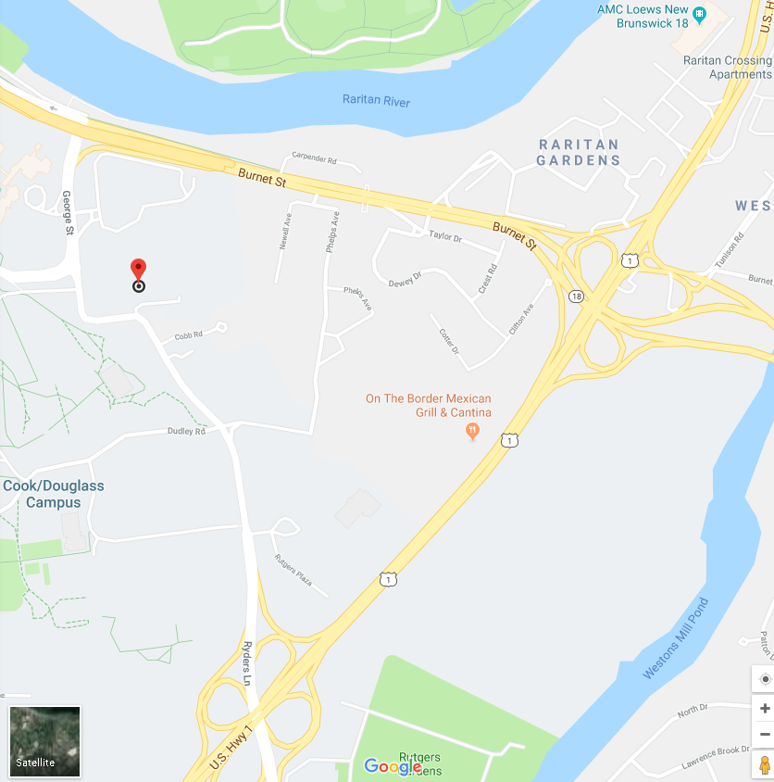

Traveling South on Route 1: After you see the AMC movie theater and pass the exit for Route 18, get in the RIGHT lane. Take the FIRST Ryders Lane exit towards New Brunswick. The exit is immediately after the Sears, BEFORE the underpass. Go through 1 traffic light. When the road curves 90 degrees to the left, the driveway/entrance to the Rutgers University Inn & Conference Center is on your right.

**Traveling North on Route 1:** After you see the College Farm Road exit, get in the RIGHT lane. Take the SECOND Ryders Lane exit towards New Brunswick. The exit is immediately AFTER the underpass. Go through 1 traffic light. When the road curves 90-degrees to the left, the driveway/entrance to the Rutgers University Inn & Conference Center is on your right.

**From the NJ Turnpike:** Take Exit 9; bear right after the toll and merge on to Route 18 North. Take the Exit for Route 1 SOUTH. Stay in the RIGHT lane. Take the FIRST Ryders Lane exit towards New Brunswick. The exit is immediately after the Sears, BEFORE the underpass. Go through 1 traffic light. When the road curves 90-degrees to the left, the driveway/entrance to the Rutgers University Inn & Conference Center is on your right.