NJSLA September Technology Event

The New Jersey Chapter of SLA presents:

“Artificial Intelligence and Ethics”
Speaker: John C. Havens

John C. Havens is Executive Director of The IEEE Global Initiative on Ethics of Autonomous and Intelligent Systems. He is tasked with coming up with new models that put human well-being at the forefront. That means empowering designers of AI/AS systems with the training and tools they need to prioritize ethical considerations in their work, and coming up with new ways to measure success that don’t put profits and output ahead of people and planet.
John is also a contributor on issues of technology and well-being to Mashable and The Guardian and is author of the books, Heartificial Intelligence: Embracing Our Humanity To Maximize Machines and Hacking Happiness: Why Your Personal Data Counts and How Tracking it Can Change the World.

Where: | When:
IEEE | Thursday, September 12, 2019
445 Hoes Lane | 5:30 - 6:00 Networking
Piscataway, NJ 08854  Picture ID is required for entry  No entry after 6:30 p.m. | 6:00 - 7:00 Dinner  7:00 - 8:00 Speaker

The chapter gratefully acknowledges our sponsor for making this event possible:

www.librarylinknj.org

Payment Online | Payment by Mail
https://njsla-event-registration-sep-2019.eventbrite.com  EventBrite, the online registration site, allows payment  by credit card or check.  .  Please Register Online by Thursday, Sept. 5, 2019  Picture ID is required for entry. No entry after 6:30 p.m. | To pay offline, complete the bottom portion  of this form, and make your check out to NJSLA.  Mail both by Sept. 5 to:  Joy Whitney  Edison Partners  281 Witherspoon St., Suite 300  Princeton, NJ 08540  Email: jwhitney@edisonpartners.com

------------------------------------------------------------------------------------------------------------------------------------------------
☐ SLA/SCIP/ALA/AIIP/NJLLA-Members (any chapter) $30
☐ Non-Members $40
☐ Members who are Retired or Not Working / Any Students $20

Thursday, Sept. 12, 2019 @ IEEE, 445 Hoes Lane, Piscataway, NJ 08854

NAME _____________________________________ COMPANY_________________________________________

TITLE ___________________________________________________________________________________________

PHONE ____________________________ EMAIL____________________________________________________
Are you a first time attendee? __________ Would you like to be a buddy to a first time attendee? ____________

NOTE: Dinner will be served buffet style, with a variety of choices available. Please notify us if you have special dietary needs. | Total Enclosed $_________________

------------------------------------------------------------------------------------------------------------------------------------------------

INFORMATION AND DIRECTIONS

IEEE
445 Hoes Lane
Piscataway, NJ 08854

- There is a smaller parking lot in the front of the building, and a much larger parking lot behind the building. You must enter in the front of the building by the flag poles. There is a sidewalk from the back parking lot to the front of the building.

- IEEE Security will be checking visitors in until 6:30 pm, so please arrive before then. No one will be permitted to enter after 6:30 pm.

- A picture ID is required. A government issued ID such as a driver’s license or passport is preferred.

- Registration closes on 9/5 so that IEEE has a list of all attendees with names, affiliations, and professional titles by 9/6.

- Badges will be prepared in advance for all attendees so there is no holdup at the front desk and IEEE personnel will escort attendees to the room.

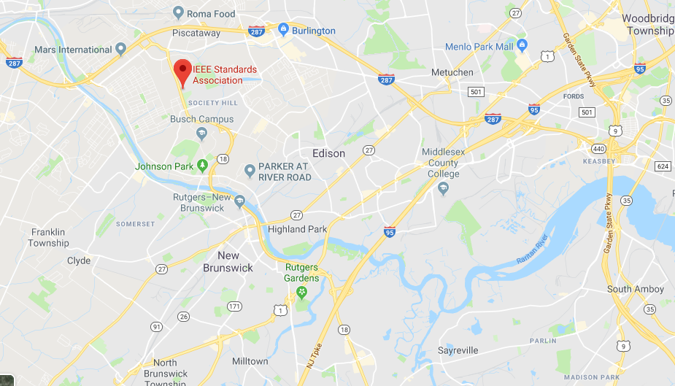

DIRECTIONS to IEEE, 445 Hoes Lane, Piscataway, NJ 08854

From Route 287

From North of Piscataway: Take 287 South to Exit 8 (Centennial Ave.). At the end of the exit ramp, continue straight through the traffic signal onto Knightsbridge Rd.
At the second traffic signal, turn right onto Hoes Lane. The IEEE Operations Center is a 1/4 mile up on the left. Turn left onto Sidney Rd to enter the IEEE parking areas.
From South of Piscataway: Take 287 North to Exit 7 (South Randolphville Rd.). At the bottom of the ramp, turn left and continue on South Randolphville Road, through three traffic signals.
After the third signal, the road narrows. Continue on Behmer Rd. After crossing a small bridge, turn left onto Sidney Rd. The IEEE Operations Center will be on the right near the end of Sidney Road.

From NJ Turnpike
- Take the Turnpike to Exit 10 (signs will say Edison, Route 287, Outerbridge Crossing).
- After the toll plaza, take 287 North for approximately 5.5 miles, and take Exit 7 (South Randolphville Road). Follow directions from Route 287 South above.

From Route 18
- Driving north on Route 18, cross over the John Lynch bridge continuing straight. Route 18 becomes Hoes Lane.
- At the fifth traffic signal, make a right turn onto Sidney Rd. and then a quick left into IEEE parking areas.

By train
- Take New Jersey Transit (NJT) to the New Brunswick, NJ station.

