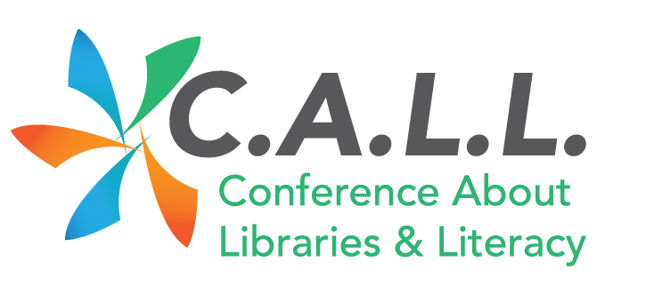

C.A.L.L.: Conference About Libraries & Literacy
Thursday, February 1, 2018
https://callconferenceblog.wordpress.com/

It is our distinct pleasure to invite you to the second Conference About Libraries & Literacy (C.A.L.L.). The conference is a collaboration between UW-La Crosse Murphy Library, the School District of La Crosse & La Crosse Public Library and will take place on the UW-La Crosse campus on Thursday, February 1, 2018. Librarians from all types of libraries (school, public, academic, special, etc.) are welcome to attend.

In an age of globalization, interdependence is something we should embrace. K-12 students become the community citizens and/or college students of tomorrow. Librarians touch their lives from the beginning of their school years through high school graduation; to after-school-hours and summer programming or as a safe place to go when school libraries close; to vocational job training or university research. Networking and collaborative initiatives between these groups is the direction of this conference.

The theme of the conference will be “Librarians as Advocates.” In a world where funding and investment in libraries is a constant battle and where libraries and their staff are sometimes perceived as outdated and irrelevant to life in the 21st century, how can librarians advocate for libraries and for their profession? Additionally, with threats to net neutrality, copyright, fair use, privacy and confidentiality, how can librarians also advocate for their patrons and their communities? And finally, how can librarians from various types of libraries work together to be advocates for each other and for our libraries?

We are delighted to invite presenters on the following topics of interest that may include, but are not limited to:
- Successful collaborations for libraries and literacy
- Innovative programs or initiatives which feature advocacy for libraries and literacy
- Beyond Google: how to advocate for library resources

Submission Details
To submit a conference proposal, please use the submission form. The deadline to submit proposals is Thursday, November 30, 2017. The committee invites proposals that address current challenges faced by professionals in the field and are solution-oriented as well as stimulate and provoke discussion and audience engagement. Presentation sessions are 30 minutes each with 15 minutes scheduled for questions/discussion. Collaborative and interactive presentations are encouraged and panel presentations are also accepted. Notification of acceptance will be Friday, December 15, 2017.

If you have any questions or need clarification, please contact Liz Humrickhouse at ehumrickhouse@uwlax.edu.

We look forward to seeing you at the Conference About Libraries and Literacy!

Cindy Halter, School District of La Crosse
Teri Holford, UW-La Crosse Murphy Library
Liz Humrickhouse, UW-La Crosse Murphy Library
Linda Jerome, La Crosse Public Library

