Special Libraries Association – Kentucky Chapter
November 7, 2016

Slate of Nominees for 2017

President Elect: Linda Turner, American Printing House for the Blind.

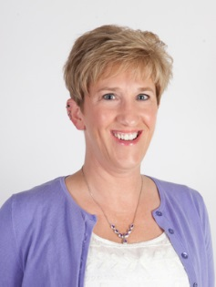

Linda Turner is the Technical Services & Digital Resources Manager at the American Printing House for the Blind (APH), located in Louisville, Kentucky. Linda received her MSLS from the University of Kentucky. She spent 10 years in North Carolina working for the Health Sciences Library at East Carolina University and MAHEC, where she served as Treasurer and Webmaster for ANCHSL. Linda has been a member of SLA since 2006 and has served as the Mentorship Committee Chair, Director-at-Large, and Webmaster for the Kentucky Chapter of SLA.

Treasurer: Abby Thorne, UK Health Care’s Don and Cathy Jacobs Health Education Center.

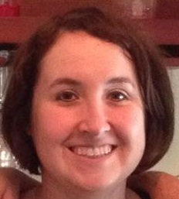

Abby Thorne received a Bachelor of Science degree in Agricultural Education, Communications, and Leadership in 2004 and a Master of Science degree in Library Science in 2005 from the University of Kentucky. In 2014, she became the Health Education Coordinator for UK HealthCare's Don and Cathy Jacobs Health Education Center. Abby is a proud Kentucky Chapter member, most recently serving as Chapter Treasurer and Financial Manager of Joint Spring Conference for 2015 and 2016. She has also served the chapter as President and Director-at-Large. In 2009, she was named one of the inaugural recipients of SLA's Rising Star Award. In addition to being a member of SLA, Abby is an active member of the Midwest Chapter of the Medical Library Association and Kentucky Library Association.

Director-at-Large: Sue Finley, University of Louisville Libraries.

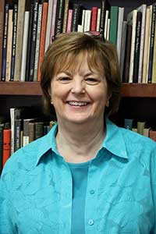

Sue Finley is the Business Librarian at the University of Louisville. After receiving her MLIS degrees from the University of Kentucky in 2006, Sue worked on digital projects in Special Collections at UofL Libraries before moving to her current position, and becoming a member of SLA, in 2011. As head of Vendor Relations for the Joint Spring Conference, she has raised money for the past three conferences, and is currently soliciting sponsorships and exhibitors for 2017.

