**MC900022214[1]**

**NJSLA Holiday Networking Party**

**Annual Business Meeting & Dinner**

**Join us in wrapping up the year and come hear about our plans for 2020!**

## *Date:* Wednesday, December 11, 2019

## *Where:* LouCas Restaurant

**9 Lincoln Highway**

**Edison, NJ 08820**

**Phone: 732-549-8580**

[**http://www.loucasrestaurant.com/**](http://www.loucasrestaurant.com/)

***Time:* 5:30 pm – 8:00 pm**

**3 Course Dinner**

**NJSLA Annual Business Meeting**

**Gloria Dinerman Memorial White Elephant Auction**

***Speaker:* Janet Weiss, NJSLA Chapter President**

***Topic:* State of the Chapter 2019**

**Enjoy our popular *"Gloria Dinerman Memorial White Elephant Auction" (optional)***

Remember that *great* gift you picked up at the White Elephant Auction last year? Here’s your chance to let

someone else share in the joy of receiving that certain something special!

If you’d like to participate, please bring a wrapped gift (something that has been lying around which you’ve been wanting to pass off on someone else OR a gift that you’ve spent no more than $25 on

OR EVEN that precious item you ended up with last year!)

This is an optional event – you simply opt-in by bringing, and walking away with, a gift!

**Special thanks to this evening’s sponsor**



**Please Make Your Reservation Online at:**

<https://www.eventbrite.com/e/njsla-holiday-party-tickets-79270069913>

*Online registration is only available by credit card. If paying by check, you must contact the person below*

*and submit payment using this form.*

*Please make the check out to* ***NJSLA*** *and return this form and your payment to:*

Joy Whitney, Edison Partners, 281 Witherspoon St., Suite 300, Princeton, NJ 08540

E-mail: [jwhitney@edisonpartners.com](mailto:jwhitney@edisonpartners.com)

***Please reserve your spot by December 3, 2019***

*If you have special dietary needs, please contact Linda Salvesen at* [*lindamsalvesen@gmail.com*](mailto:lindamsalvesen@gmail.com)

-------------------------✂-----------------------------✂-----------------------------✂---------------------------✂-----------------------

**NJSLA Business Meeting - Wednesday, December 11, 2019**

☐ Student/Retired/Between Jobs $20 ☐ SLA/SCIP/ALA/AIIP/NJLLA Members (any chapter) $30 ☐ Non-Members $40

NAME ___________________________________ COMPANY ________________________________________

PHONE __________________________ EMAIL____________________________________________________

Are you a first time attendee? _________ Would you like to be a buddy to a first time attendee? _________

*Please notify Linda Salvesen at* [*lindamsalvesen@gmail.com*](mailto:lindamsalvesen@gmail.com) **Total Enclosed $____________________**

*if you have special dietary needs*

-------------------------✂-----------------------------✂-----------------------------✂---------------------------✂-----------------------

**Directions to LouCas Restaurant**

**9 Lincoln Highway**

**Edison, NJ 08820**

*Conveniently located between the Metuchen and Metropark train stations*

*For carpooling or train pick up arrangements,*

*attendees can contact Angela Pagliaro at* [*Angela.L.Pagliaro@gmail.com*](mailto:Angela.L.Pagliaro@gmail.com)

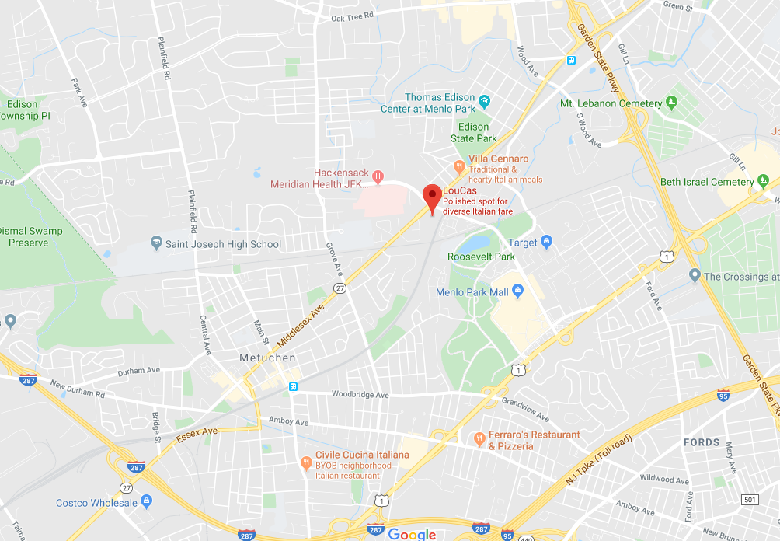

**New Jersey Turnpike (North or South)**: Take the New Jersey Turnpike to Exit 11 (Garden State Parkway turnoff). Take Garden State Parkway North to Exit 132. Turn right onto Route 27 South. Proceed to fourth traffic light and turn left onto Parsonage Road and right into parking lot of Colonial Village Shops.

**Garden State Parkway (North or South):** Take Garden State Parkway to Exit 132. Turn right onto Route 27 South. Proceed to third traffic light and turn left onto Parsonage Road and right into parking lot of Colonial Village Shops.

**Route 287**: Take Route 1 North. Turn off at Parsonage Road jug handle. Proceed to just before 4th traffic light and make left into parking lot of Colonial Village Shops.