Special Libraries Association – Kentucky Chapter

Slate of Nominees for 2018

President-Elect: Jennifer Bartlett, University of Kentucky Libraries

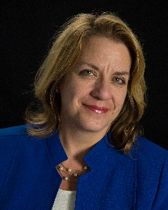

Jennifer Bartlett is the Interim Associate Dean for Teaching, Learning, & Research at the University of Kentucky Libraries, has been a member of the Special Libraries Association since 2011, and currently serves as the Secretary for the SLA Kentucky Chapter. Her first library job was as a reference librarian at The Free Library of Philadelphia in 1994. After a few years there, she made the jump to academic libraries and moved to Murray State University in Murray, Kentucky, again as a reference librarian. In 2007 she came to the University of Kentucky Libraries as the Head of the Circulation Department, and in 2010 became Head of the W.T. Young Library Reference Services Department. Jen has a bachelor’s in English and a Master’s in Library Science from Indiana University, a master’s degree in English from Murray State University, and is working on a Ph.D. in education at the University of Kentucky.

Secretary: Michele Ruth, Georgetown College Library

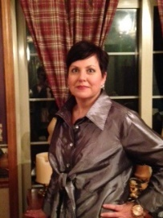

Michele Ruth is the Collection Services Librarian for the Georgetown College Library located in Georgetown Kentucky. Michele is also a graduate of Georgetown College where she worked as a library student assistant as an undergraduate. Michele has a bachelor’s degree in Business Administration and received her master’s degree in Library and Information Science from the University of Kentucky. She is a member of the American Library Association, the Kentucky Library Association and the Special Libraries Association Kentucky Chapter. She currently serves as the Director-At-Large for SLA Kentucky Chapter and has served KLA as the Chair of the Special Library Section, ALA Councilor and currently as Secretary.

Director at Large: Elizabeth Schaller, American Printing House for the Blind

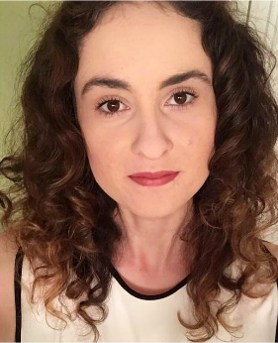

Liz Schaller is the Digital Assets and Metadata Librarian at the American Printing House for the Blind in Louisville, Kentucky, an institution dedicated to promoting “independence of blind and visually impaired persons by providing specialized materials, products, and services needed for education and life.” In this capacity, she works to support and maintain the various databases and digital resources provided to both fellow employees as well as the external community. Elizabeth earned her Master’s in Library and Information Science from the University of Pittsburgh in 2014, and an undergraduate degree in History and Art History from the University of Kentucky in 2013.

