SLA-SCC members, if you're interested in archives, learning about the history of special librarianship (and Southern California) in context, and/or planning parties, please register for this event on 3/6/21. We’re seeking both new and longtime members.

The goal is to form a committee to plan a proper celebration of the Southern California Chapter of Special Libraries Association's Centennial! 100 years! While we officially became a Chapter of SLA in 1927 ...
On March 6, 1922, a group of special librarians meet at the Realty Board Room in Los Angeles and decided to organize. They elected a President and appointed a liaison to SLA. They adopted a constitution on April 10th, and appointed a Periodicals Committee on May 8th. Pretty remarkable, just 3 years after a global pandemic, right?

So while the timing with the present day pandemic didn't work out quite right for us to plan a big celebration on March 6th of this year, there are many other milestones to celebrate between now and 2027 - 100 years after we officially became part of SLA.

This initial brainstorming session will commemorate that fateful first meeting, and kick off planning for how to use our legacy to empower special librarians in the future. Some potential tasks for committee members might be:
- Reviewing the SCC digital archive for significant figures, milestones, and for local response to current events (there are newsletters going back to 1938 - how did wartime impact this profession? - when did the internet enter the conversation? - what types of institutions had libraries in 1958? - how did we gather to network and develop as professionals?)
- Collaborating with the Archives Committee (more info coming soon) to review/exhibit significant items from the physical archive to commemorate our history
- Brilliant ideas you bring to this session which help fulfill your needs for experience in this area – if you’re looking for a side project to build your resume, this might be it.

Register here!
And if you have time, take a look through the “Newsletters and Bulletins” and “Image Archive” folders in the SLA-SCC Library on Connect (must be logged into to SLA Connect to access)
Check out the section on Southern California’s history from Special Libraries Association—Its First Fifty Years, 1909-1959
Read about SLA-SCC’s 75th Anniversary Celebration HERE (must be logged into SLA Connect to access)

Can’t wait to learn and celebrate with you.

Shelly Ray
Principal Transportation Planner, Research & Records Information Management
Office of Board Administration
LA Metro
metro.net | @metrolosangeles
Metro’s mission is to provide world-class transportation for all.

- 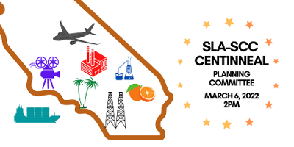

20220306-SLACC-100.png
966.6kB

